***Vodka Snow Leopard***

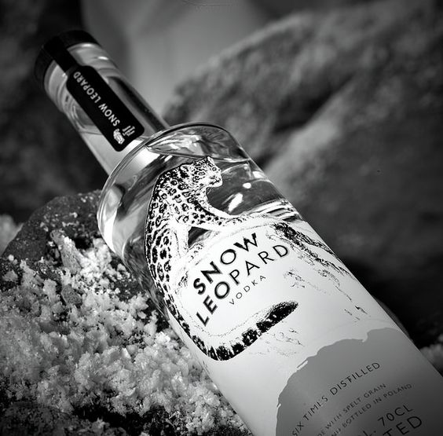

*"Snow Leopard vodka is made in Poland by Polmos Lublin, one of the finest vodka distilleries in the world. For over 100 years, Polmos Lublin has been recognized for producing some of the finest vodkas due to its skill. , experience and sophisticated distillation process.  
  
Snow Leopard is the first premium vodka made with rare spelled. Affectionately called the "grandfather of all seeds". Spelled was first cultivated more than 5000 years ago by the Egyptians.  
  
Spelled has a distinct fresh, nutty flavor. The tough shell protects the contaminant particles from the outside as well as maintaining nutrients resulting in a freshness not found in any other grain. Spelled is grown with the use of pesticides and fertilizers, and is usually purchased for four or five times the price of winter wheat or rye."*